1. **Spring-Cloud-Function Stream Processor**

可以将Function打包成Stream 任务

*./registerSupplier.sh -n wordstream -f "()->Flux.interval(Duration.ofMillis(1000)).map(i->\"message-\"+i)"*

将Lambda表达式编译成Function

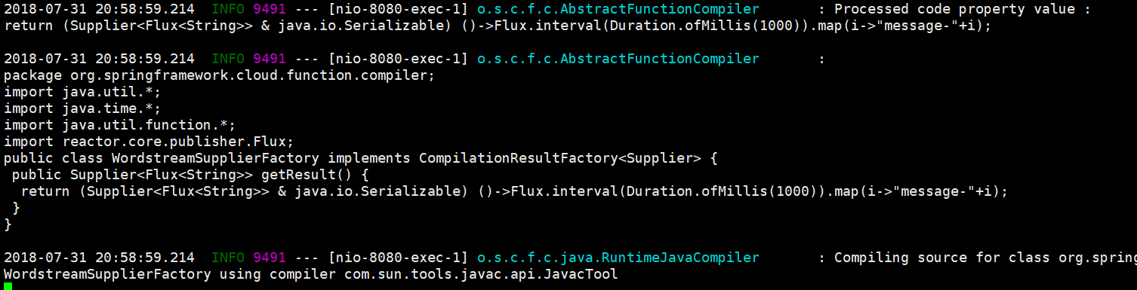

*# tree -L 1*

*├── words.fun*

*└── wordstream.fun //在suppliers中生成wordstream.fun描述文件*

启动Stream处理流程，Source: Supplier，Processor:Function和Sink:Consumer

*1)./stream.sh -p 9103 -i uppercaseWords -c print*

*2)./stream.sh -p 9102 -i words -f uppercase -o uppercaseWords*

*3) ./stream.sh -p 9101 -s wordstream -o words*

在Sink应用控制台输出MESSAGE信息（每秒输出一个消息）

*MESSAGE-0*

*MESSAGE-1*

*MESSAGE-2*

*.....*